[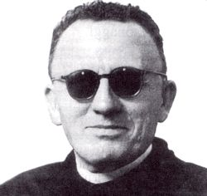](https://www.google.it/url?sa=i&source=images&cd=&cad=rja&uact=8&ved=2ahUKEwitsbC2wpvbAhXBVBQKHdVSDPkQjRx6BAgBEAU&url=http%3A%2F%2Fwww.centrostudibeppefenoglio.it%2Fit%2Farticolo%2F4-29-995%2Fpersonaggi%2Fnon-albesi-nella-toponomastica%2Fbussi-natale&psig=AOvVaw1XSWOaJ8ao9SZN_2xUQHL5&ust=1527154079844834)[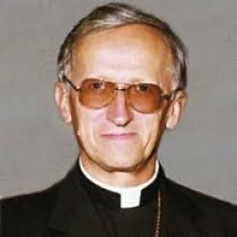](https://www.google.it/url?sa=i&source=images&cd=&cad=rja&uact=8&ved=2ahUKEwjA48TdwpvbAhUGWhQKHchQC1AQjRx6BAgBEAU&url=http%3A%2F%2Fazionecattolica.it%2Fmons-piero-rossano-maestro-di-dialogo&psig=AOvVaw3Z_orv7oFaSvwO1opA-r-t&ust=1527154160189389)